# Spring Framework – Exercise 1 & 2 Implementation Report

## Exercise 1: Configuring a Basic Spring Application

### 1. Project Setup

Created a Maven project named LibraryManagement.

Added Spring Core dependency in pom.xml:

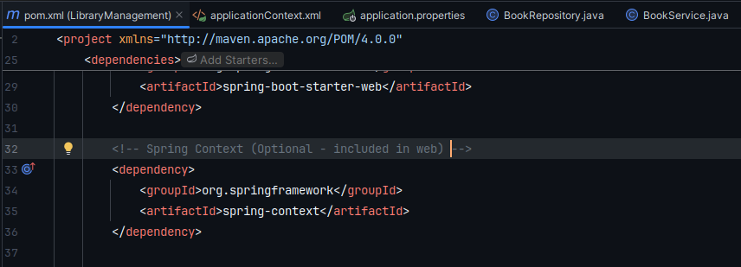

### 2. XML Configuration

Created applicationContext.xml under src/main/resources

Defined beans for BookService and BookRepository

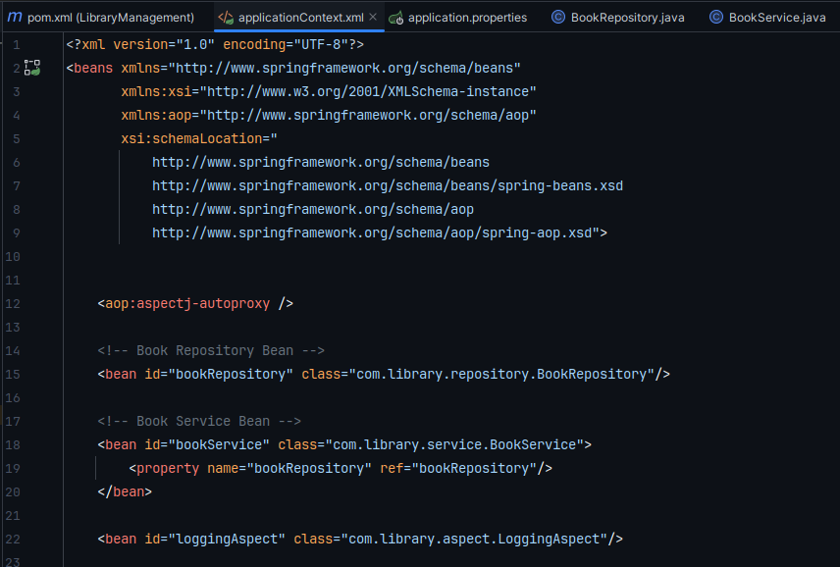

### 3. Service and Repository Classes

**BookRepository.java**

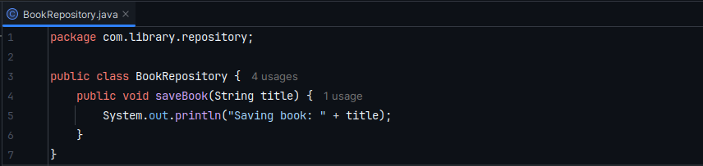

**BookService.java**

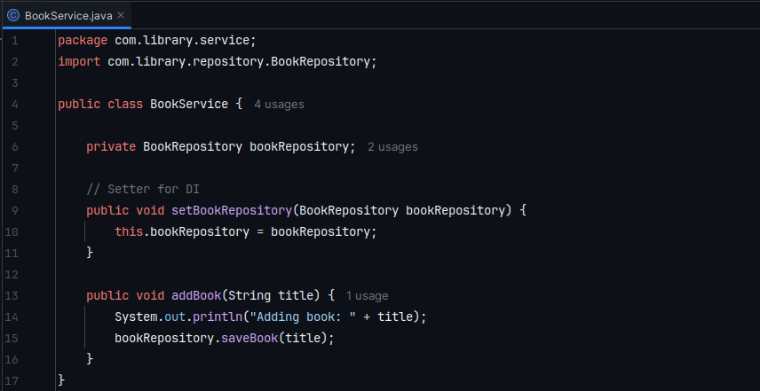

### 4. Main Class for Testing

**LibraryManagementApplication.java**

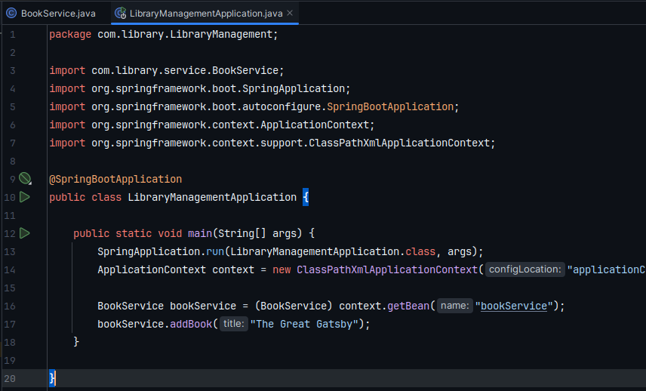

## Exercise 2: Implementing Dependency Injection

### 1. XML Configuration Updated

Confirmed bookRepository is injected into bookService using <property> tag.

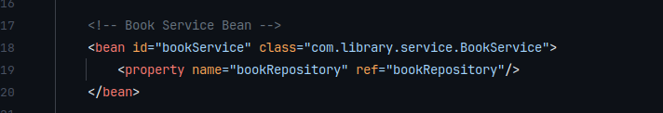

### 2. Setter in BookService

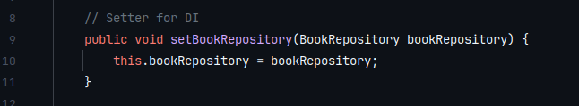

### 3. Execution Result

Ran LibraryManagementApplication.java

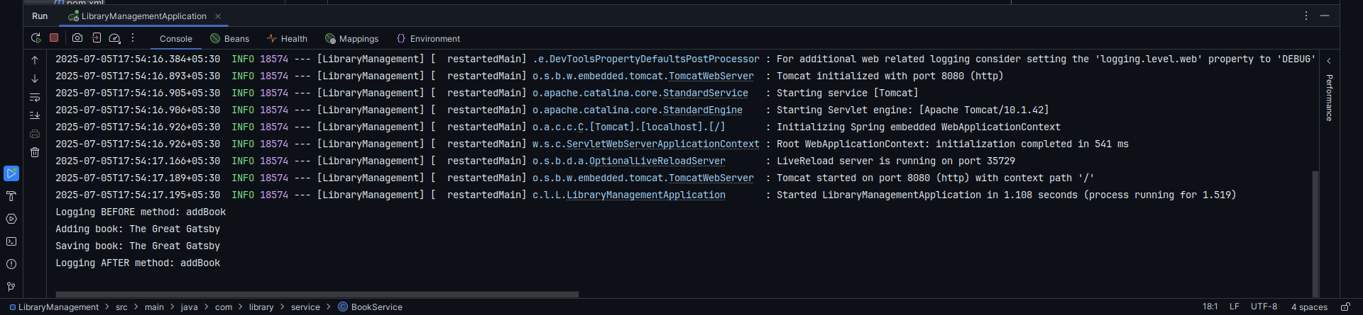

## Project Structure Overview

src/main/java/com/library/repository → BookRepository.java

src/main/java/com/library/service → BookService.java

src/main/java/com/library → LibraryManagementApplication.java

src/main/resources → applicationContext.xml

pom.xml → Spring Core dependency

